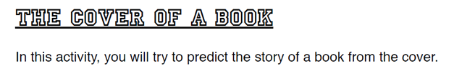
FEATURE |  | MEANING OR MESSAGE |  | YOUR JUDGEMENT
What images do you see? They could be people or objects. (Describe the image) |  | What does each image represent? What possible message is being communicated by the image? |  | Is it appealing to you? Do you think the images used are creative and meaningful? | Comment:
What is in the foreground? |  | Why is it in the foreground?
What is in the background? |  | Why is it in the background?
What are key words or phrases used in the title and subtitle? |  | What connotative (related) meaning is being communicated by these key words? |  | Is it effective in enticing you to read the story?
What other words or phrases are included in the front cover? |  | What is it purpose?
What are the dominant colours used? |  | Why might these colours have been used? |  | Do you find the colours/design visually appealing?

